**16. Create an EC2 instance with 8 GB storage.**

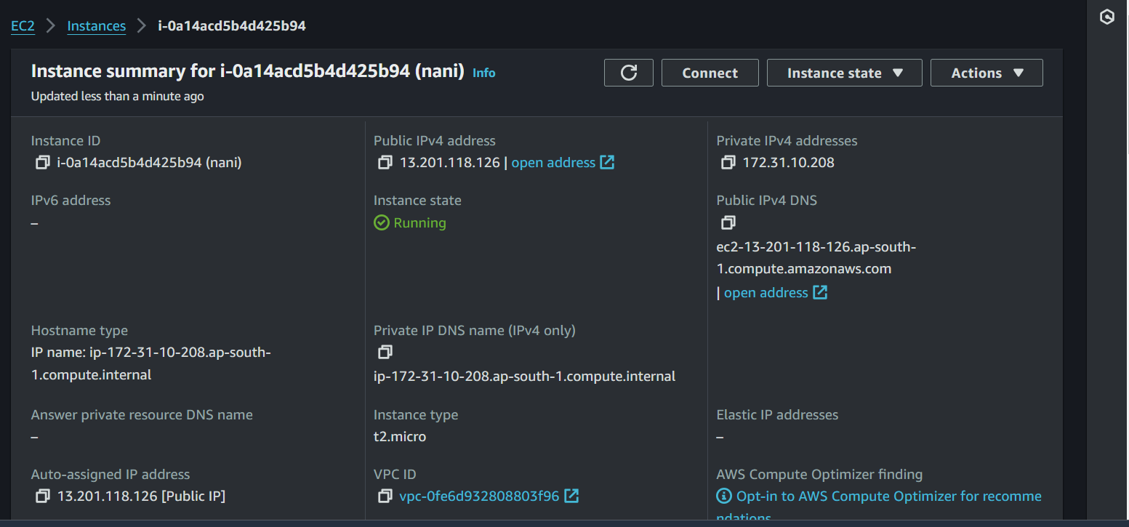

**17. Create a snapshot for the EC2 instance's EBS volume.**

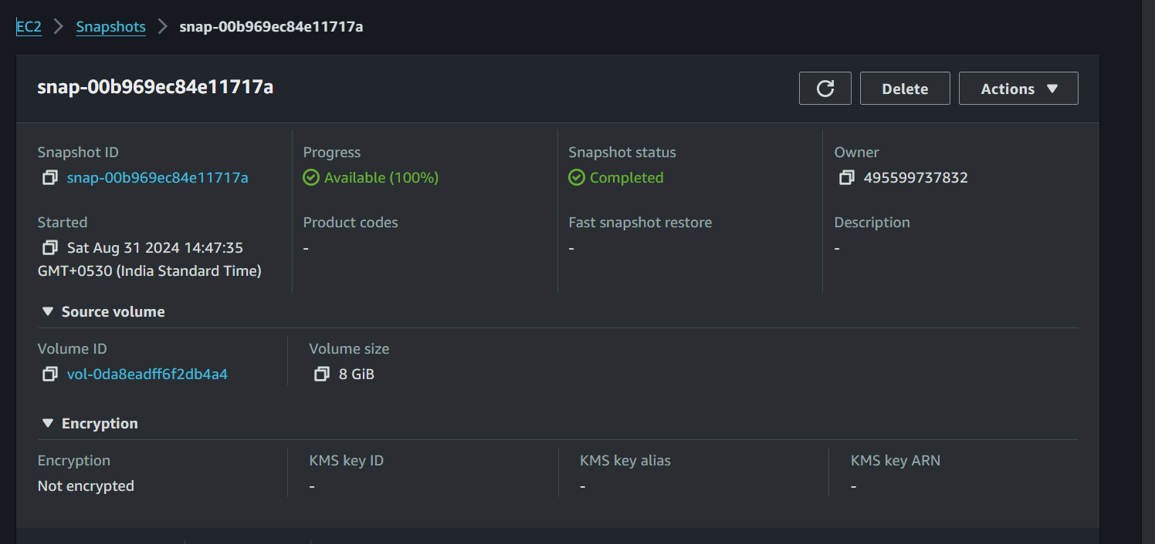

**18. Extend storage by an additional 8 GB for the running instance.**

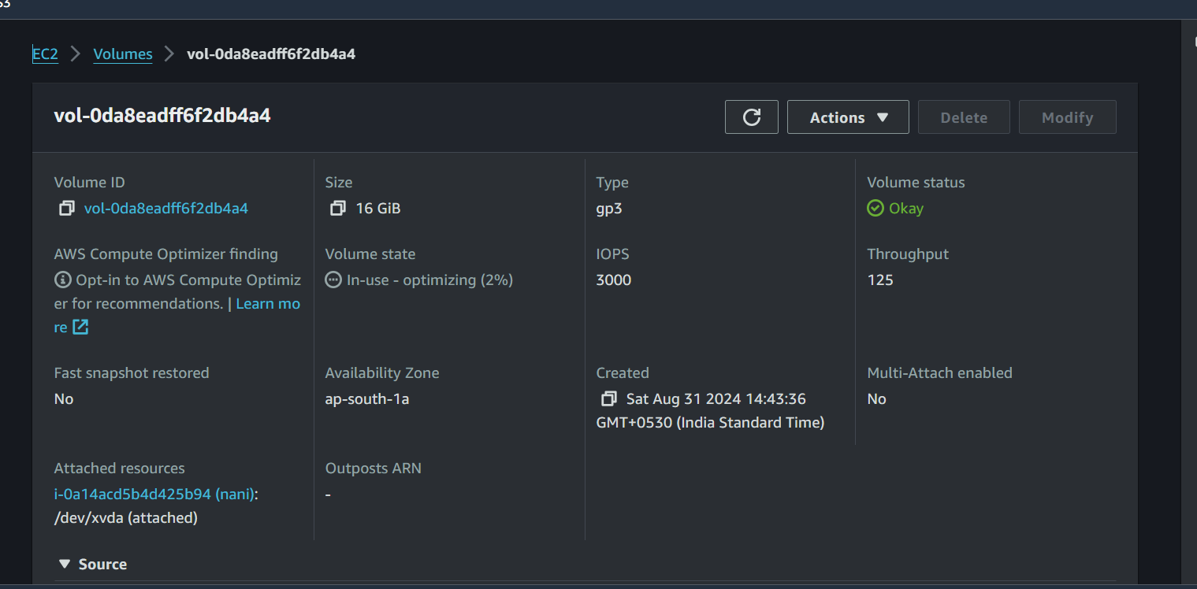

**19. Delete the snapshot created earlier.**

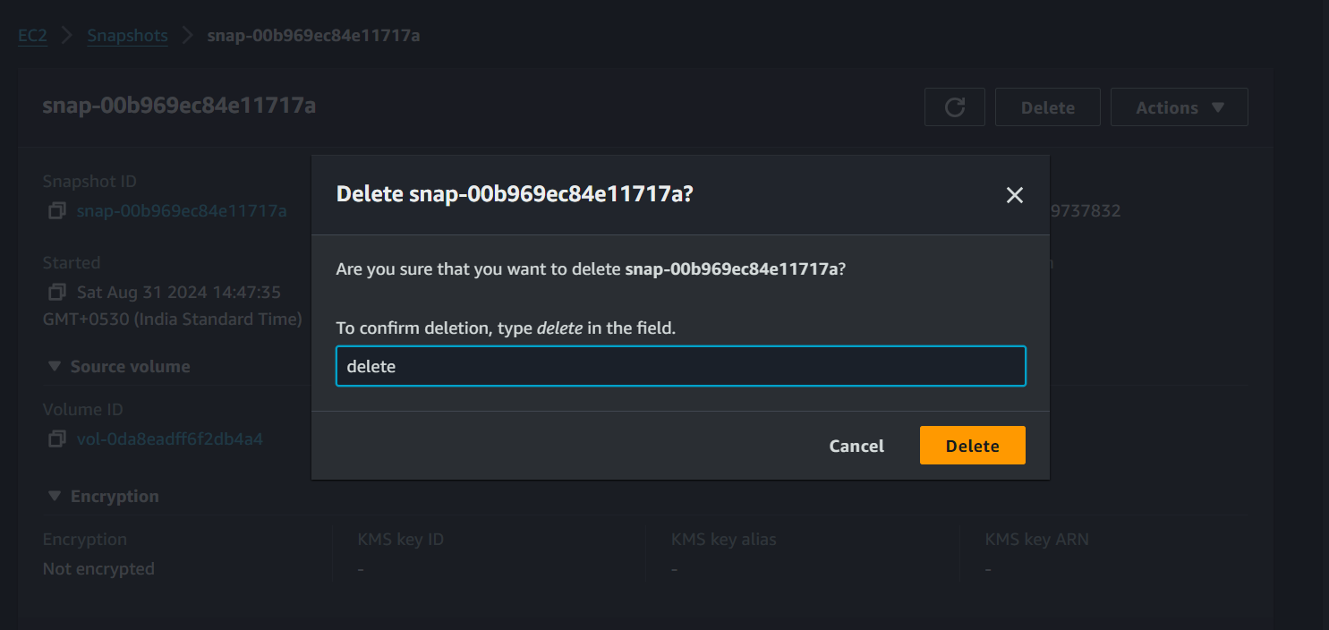

**20. Instructions on how to connect to an EC2 instance if the PEM key is lost with images**

Created an new instance-1 and some content(with file **f1** and file **f2**) in the this instance

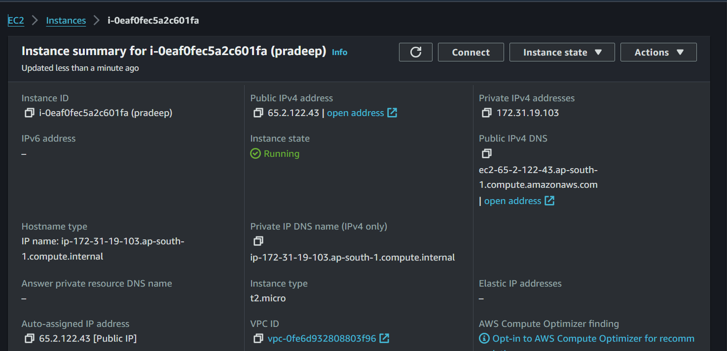

**Stopped the created instance-1**

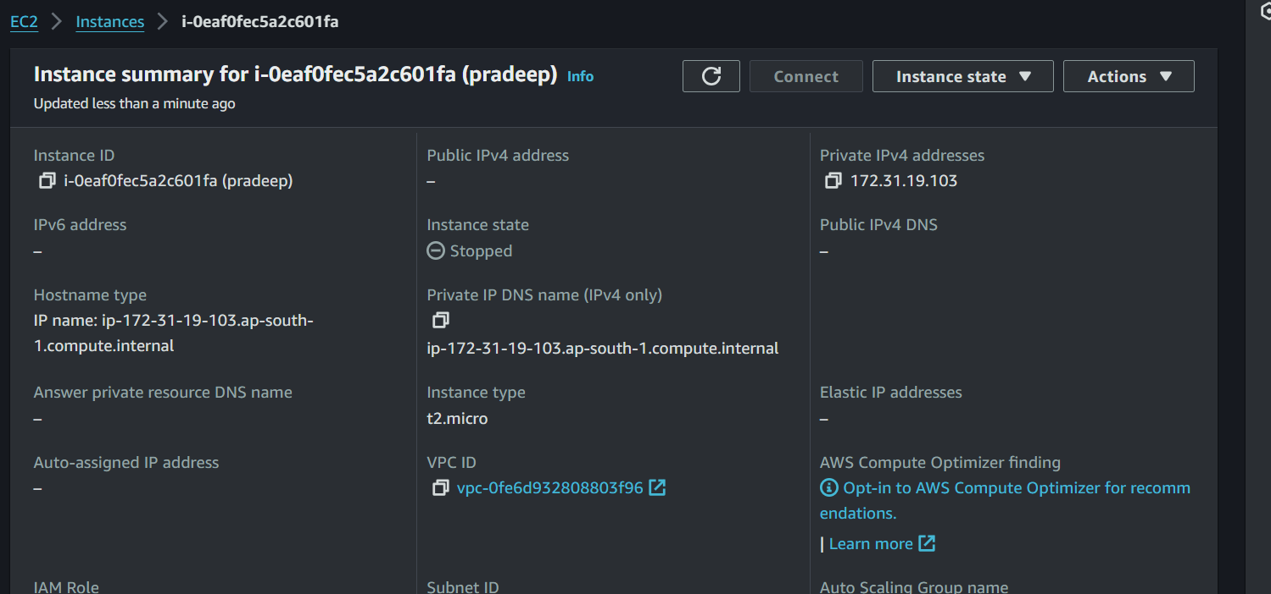

**Detached the volume of instance-1**

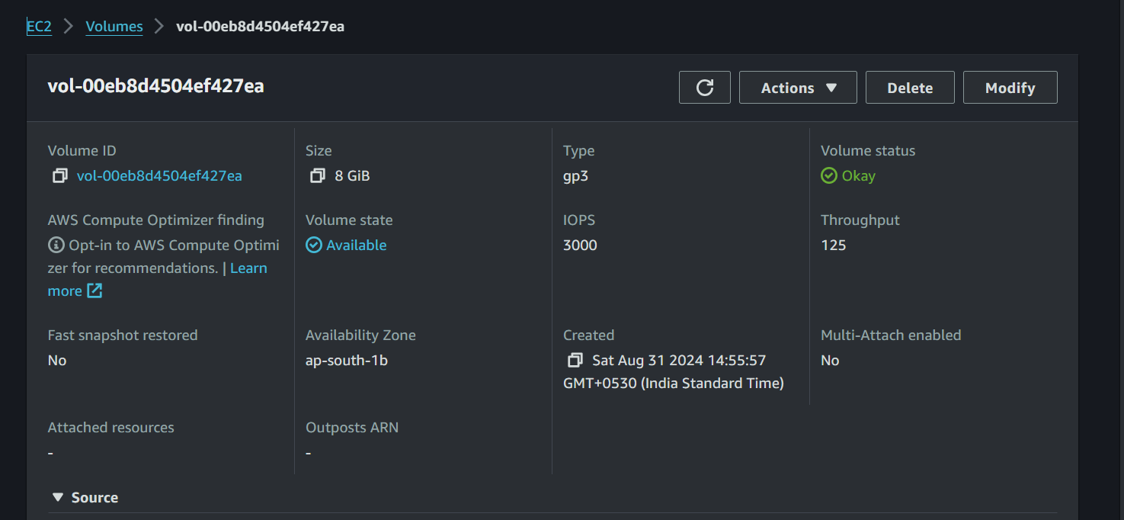

**. Created a new instance with pradeep-1 and attach the detached volume to the new instance with device name /dev/sdf**

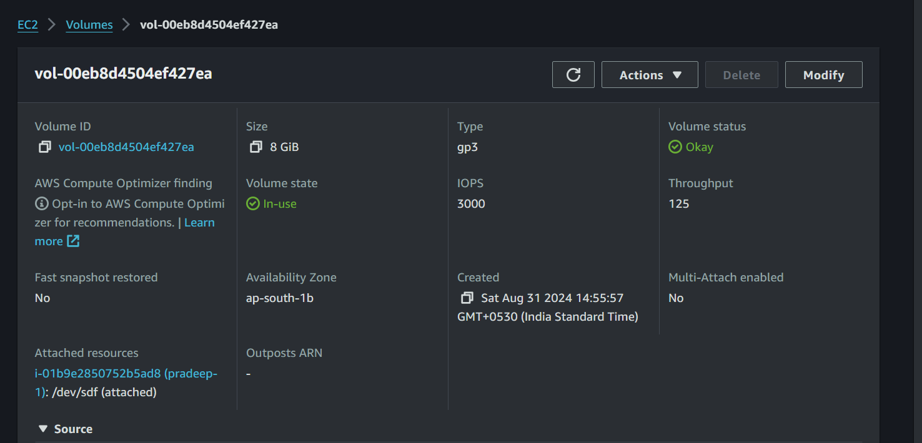

**After attaching the detached volume of instance-1.The content in the instance-1 be displaying in the instance-2(pradeep-1)**

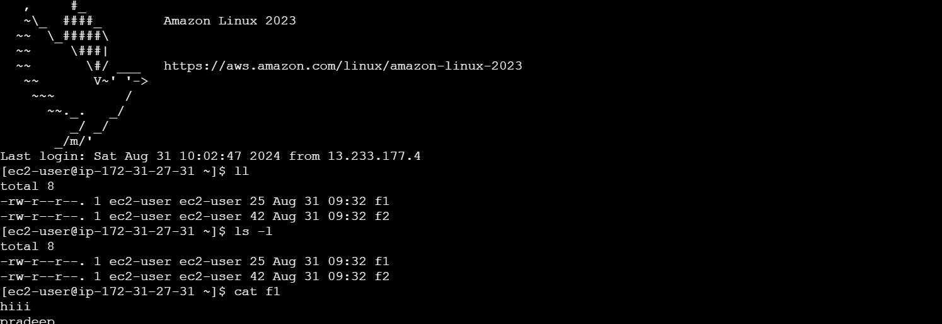

**21. Create instance-1 in ap-south-1a with an 8 GB volume.**

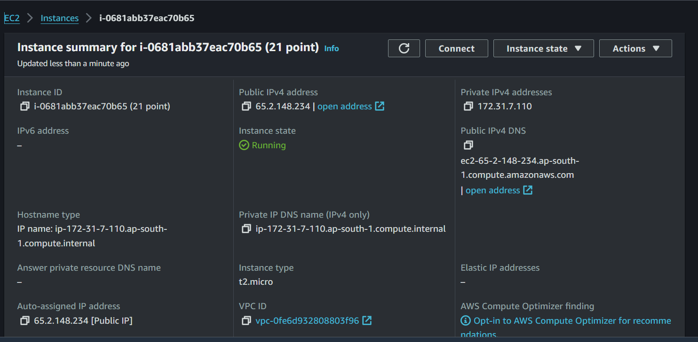

**Volume of Instance-1**

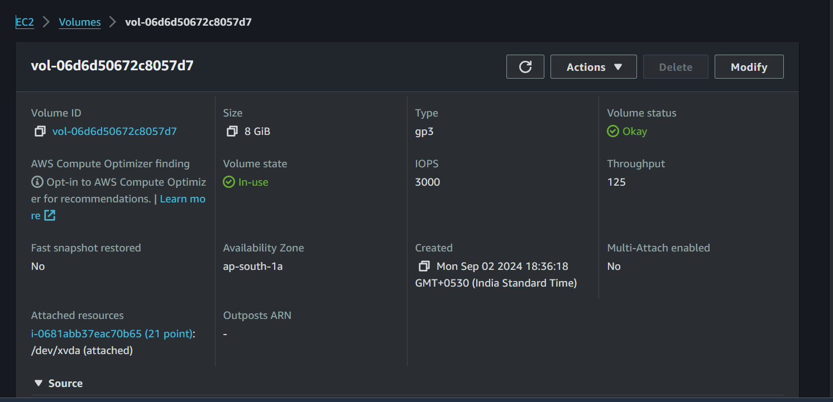

**22. Create instance-2 in ap-south-1b with an 8 GB volume.**

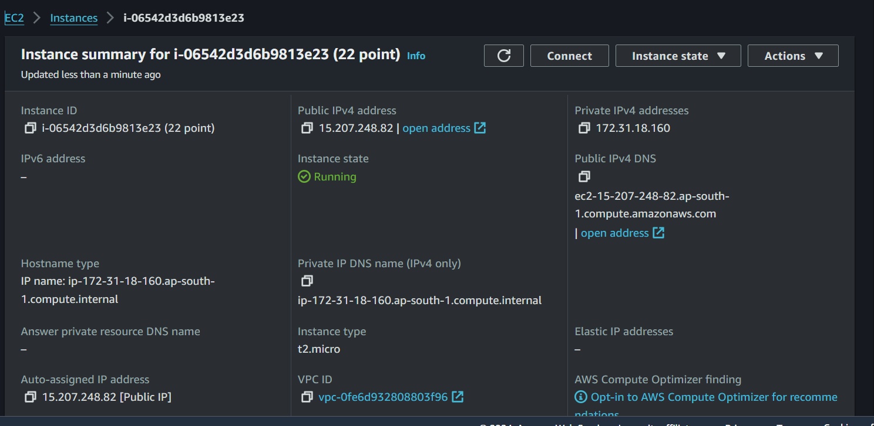

**Volume of Instance-2**

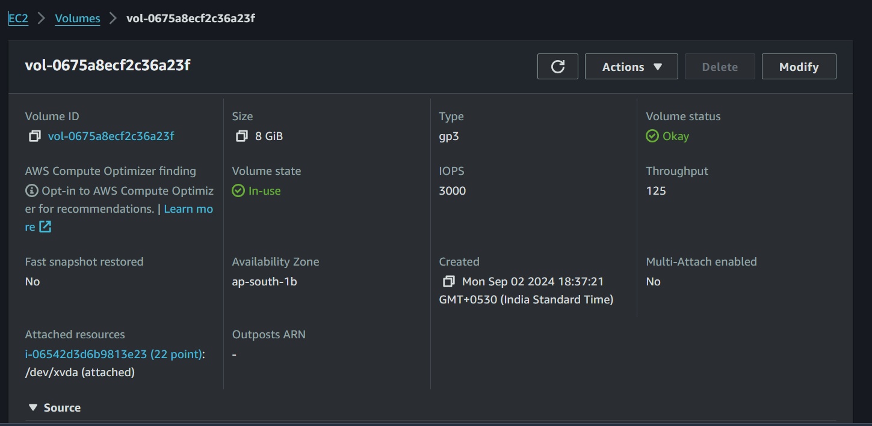

**23. Stop and detach the EBS volume from instance-1 and attempt to attach it to instance-2. Determine if this is possible and under what conditions (hint: it depends on the specific volume type created). Find a solution for this scenario.**

Stop and detach the EBS volume from instance-1 and it is not possible in different availability zones to attach it to instance-2

**Solution is**

**1)create the snapshot of using volume 1 before detach the volume-1**

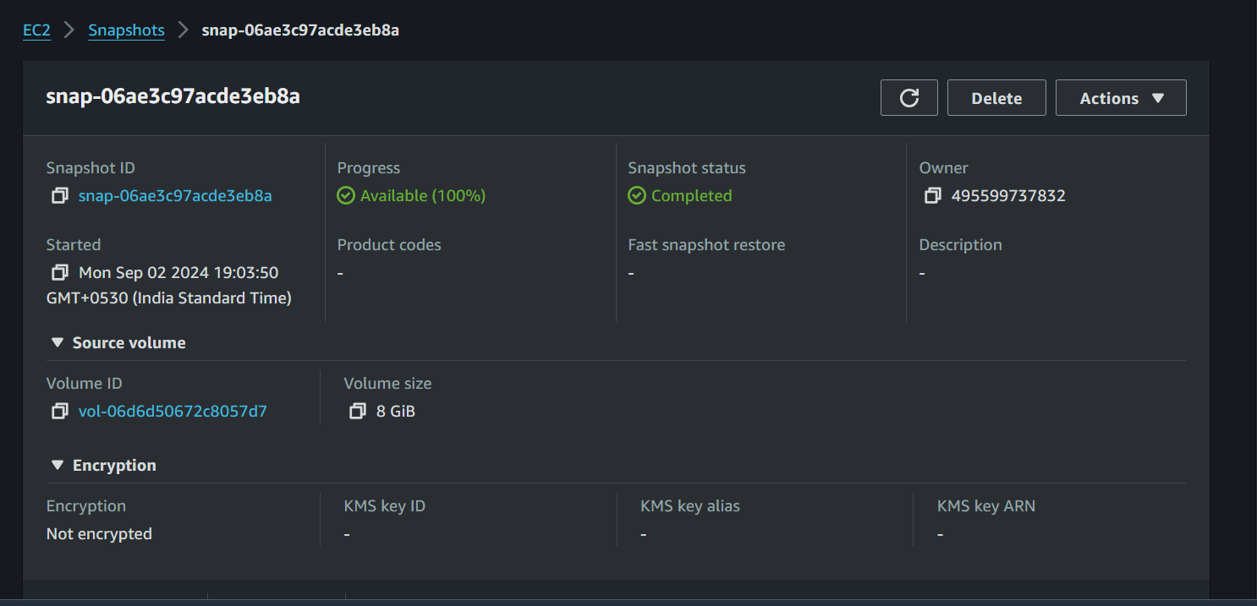

**2) Go to instances and stop the instance-1**

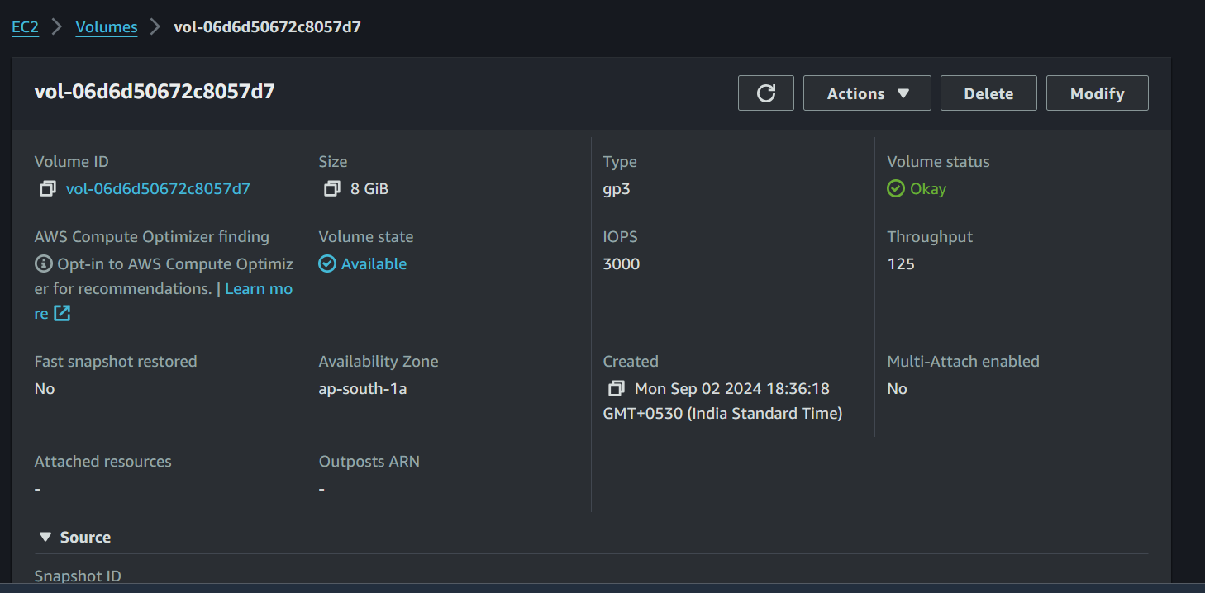

**3)Detach the volume of instance-1**

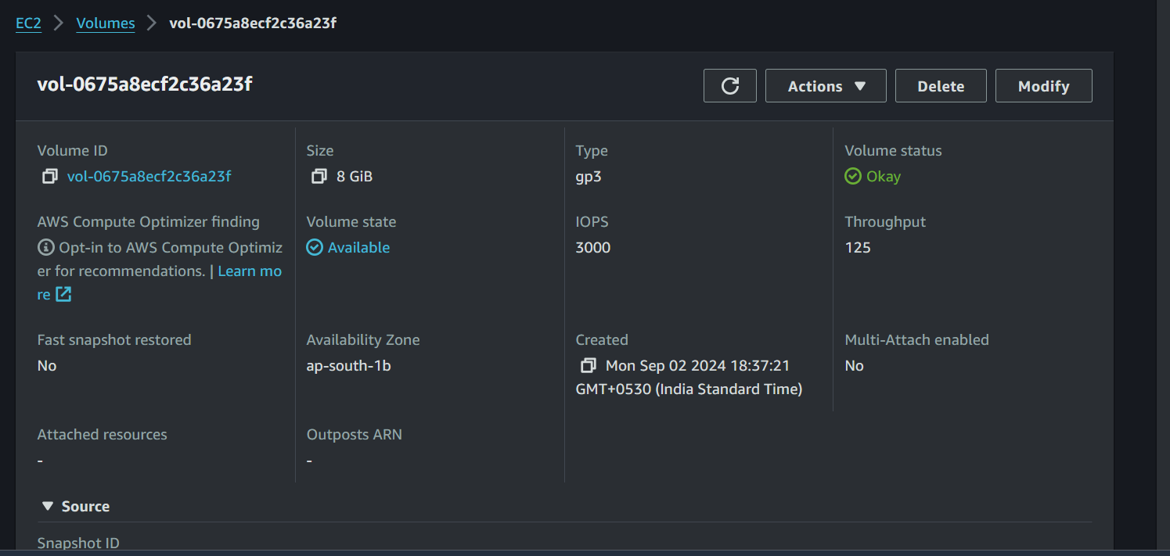

**4)Now create the volume from snapshot**

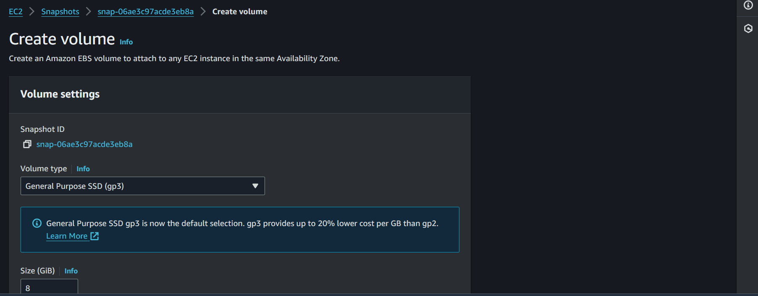

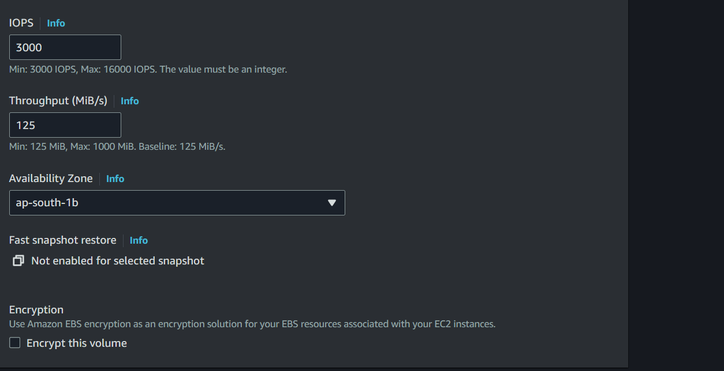

**5)After creating the volume from snapshot attach the volume to the instance-2(22 point)**

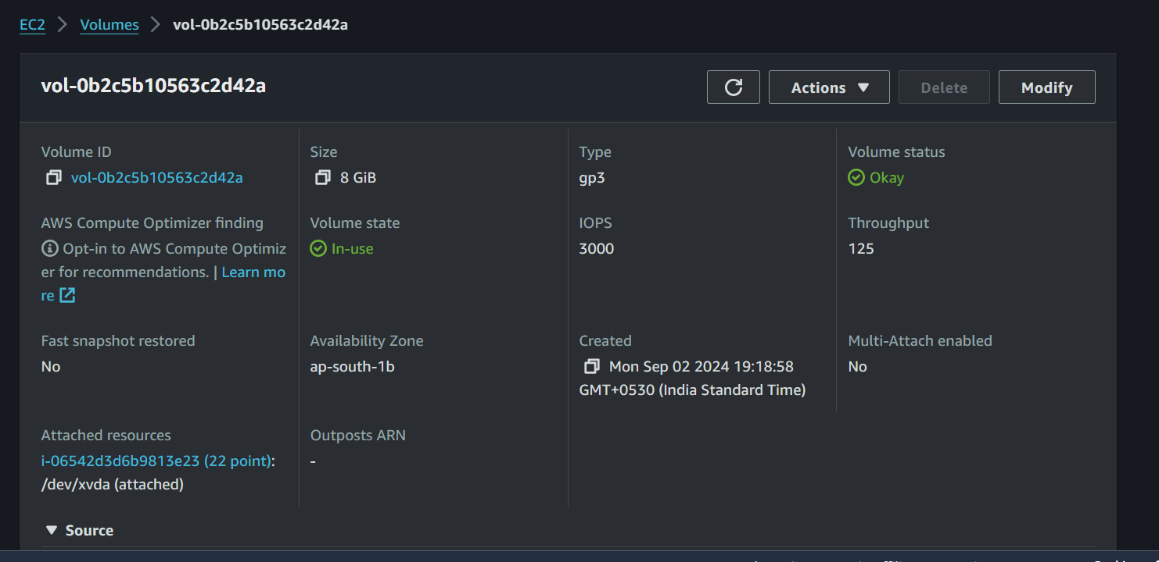

**6)After attaching the volume to the instance-2 the content in the instance-1 be converted to the instance-2**

